1、Base on the core we can find the process hung when access the inode 0xb000200:

crash> struct nameidata ffff883fb3c6be98 | grep inode inode = 0xffff881f60e87590,crash> crash> struct inode 0xffff881f60e87590 | grep i_ino i_ino = 0xb000200,crash> crash> eval 0xb000200hexadecimal: b000200 decimal: 184549888 octal: 1300001000 binary: 0000000000000000000000000000000000001011000000000000001000000000crash>

2、find all extents of this inode:

xfs_db -f /dev/sds -c "inode 184549888" -c p

……………

……………

u.bmx[0-27] = [startoff,startblock,blockcount,extentflag] 0:[0,92274928,16,0] 1:[16,92275163,32,0] 2:[48,92274912,16,0] 3:[64,92279954,16,0] 4:[80,92280002,16,0] 5:[96,92295660,16,0] 6:[112,92413160,16,0]

7:[128,92418278,16,0] 8:[144,92515562,16,0] 9:[160,92521441,16,0] 10:[176,92551662,16,0] 11:[192,92557537,16,0] 12:[208,92557664,16,0] 13:[224,92593130,16,0] 14:[240,92610030,16,0] 15:[256,92625378,16,0]

16:[272,92676842,16,0] 17:[288,92718824,16,0] 18:[304,92730849,16,0] 19:[8388608,92274976,16,0] 20:[8388624,92279970,32,0] 21:[8388656,92297967,16,0] 22:[8388672,92467681,16,0] 23:[8388688,92544954,16,0]

24:[8388704,92558059,16,0] 25:[8388720,92655339,16,0] 26:[8388736,92635694,16,0] 27:[16777216,92279938,16,0]

3、The magic of 19:[8388608,92274976,16,0] should be 0xfebe, but now it is 0xd2f1, so we know the meta-data is wrong.

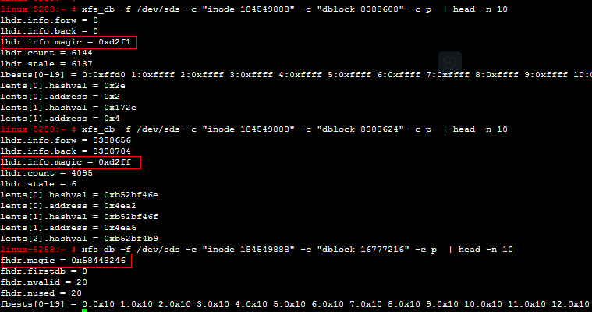

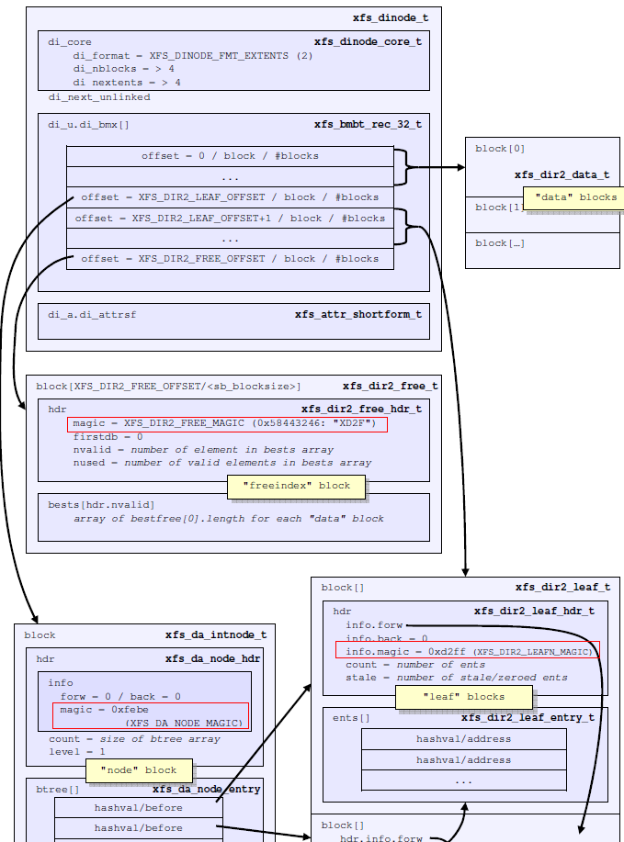

4、 Find out the inode 184549888 is place on No. 0x20057000 sector:

1）collect info of superblock：

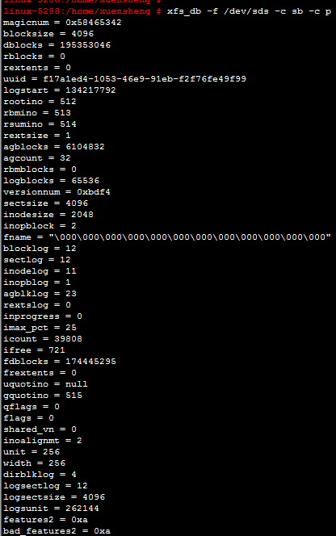

agblocks=6104832   agblklog = 23  inoplog=1

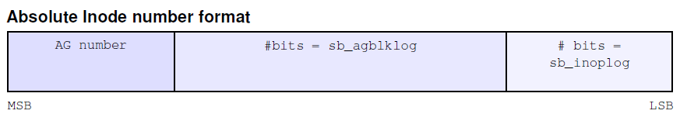

According to the above information of superblock we can know why inode 184549888 is placing in **No.** 0x20057000 sector:

Inode 184549888 is equal to hex 0xB000200

AG number =  0xB000200 >> (23 + 1) = 0xB = 11

ag block = 0x200  >> 1 = 0x100 = 256

AG_number * agblocks + ag_block = 11 * 6104832   + 256 = 67153408

Block*(block size/sector size)= 67153408 * (4096 / 512) = 537227264 = 0x20057000

19:[8388608,92274976,16,0]:

92274976 is equal to hex 0x5800120

AG_number = 0x5800120 >> 23 = 0xb = 11

ag block = 0x5800120 & (( 1 << 23) – 1) = 0x120

 AG_number * agblocks + ag_block = 11 * 6104832 + 288 = 67153440

Block*(block size/sector size) = 67153440 * （4096 / 512） = 537227520 = 0x20057100

We can find following message in /var/log/message:

Jun 30 15:50:16 linux-5288 kernel: [1506257.413164] XFS (sds): Device sds: metadata write error block 0x20057000

So we know the inode 184549888 write failed on Jun 30.

5、 Collect information of XFS log about inode 184549888 and block 19:[8388608,92274976,16,0]

Collect the XFS log information via “xfs_logprint –o /dev/sds”:

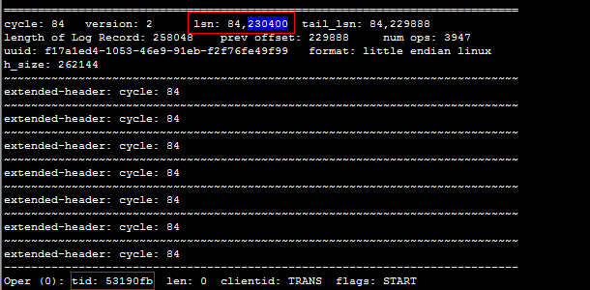

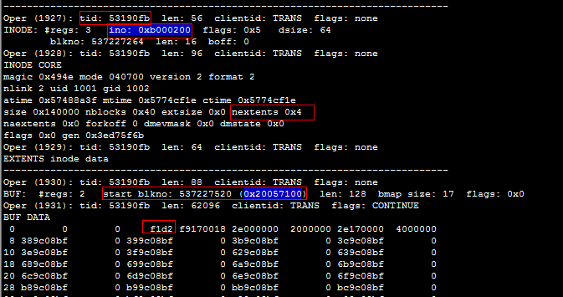

According to the above information we can know the nextents of inode 184549888 (0xb00200)should be 0x4, but in fact we find the core.nextents is 28 via following command:

cid:image019.png@01D1DEC0.A823A350

So we know the XFS filesystem recover the inode 184549888 failure.

But why the XFS filesystem recover this inode failed? We continue to analyze this issue:

6、

We can find following error messages via /var/log/message:

Jun 30 15:50:27 linux-5288 kernel: [1506268.259835] XFS (sds): I/O error occurred: meta-data dev sds block 0x2e975e00       ("xlog_iodone") error 5 buf count 262144

Collect the LSN via “xfs_logprint”:

xfs_logprint –o /dev/sds | grep lsn

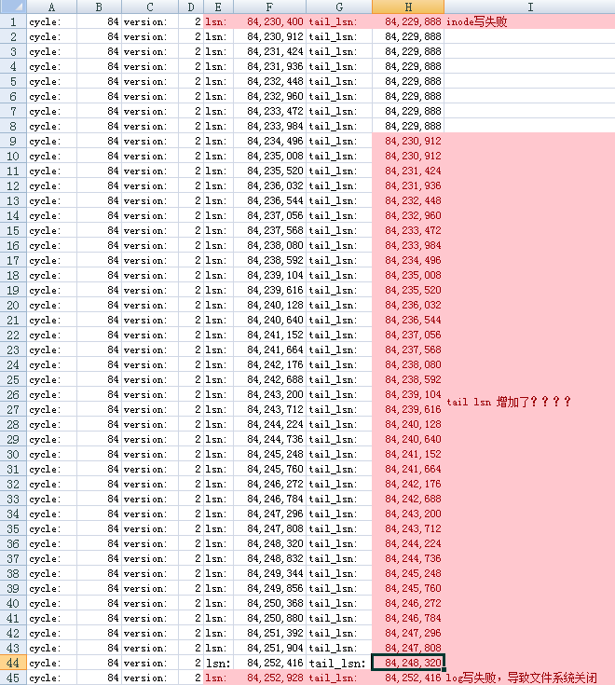

cid:image020.png@01D1DEC0.A823A350

134217792 + 252928 / (4096/512) = 134249408 (0x8007bc0)

(0x8007bc0 >>23)=0x10

0x8007bc0 &(( 1 << 23) – 1)=0x7bc0

0x10*6104832(agblocks)+ 0x7bc0=0x5d27000+0x7bc0=0x5d2ebc0

0x5d2ebc0*（4096 / 512）= 0x2e975e00

So we know the LSN 84252928 write failed.

7、

According to the information below, we know the LSN from 84230400 to 84252416 are all on the same transaction

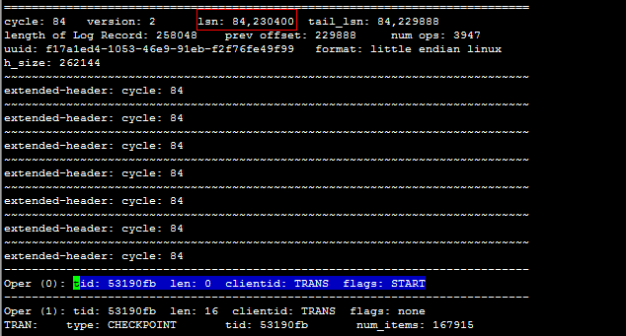

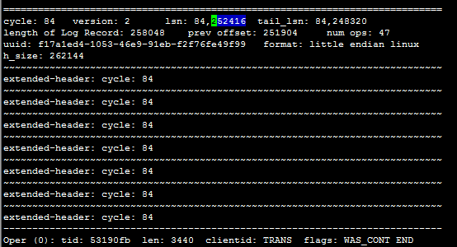

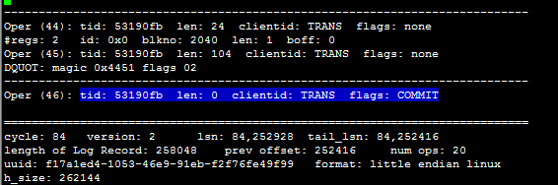

Analyze the “xlog_assign_tail_lsn”, we can know LSN of this LR will become the new tail_lsn when “xfs_ail_min_lsn” returns 0.

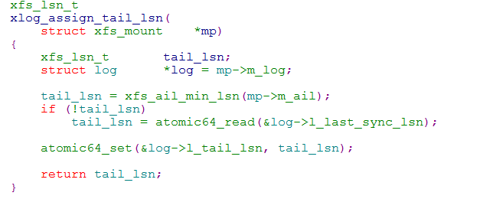

Continue to analyze the “xlog_state_do_callback”, we know the last_sync_lsn is updated with iclog’s LSN.

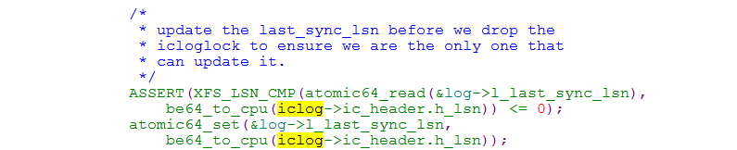

Therefore, when LSN 84252928 write failed, the XFS filesystem only to recover the data from tail_lsn(84248320) to lsn(84252416), it did not recover the LSN 84230400 although the LSN 84252416 and 84230400 are in the same transaction.

This means the XFS filesystem did not recover the inode 184549888 and block 19:[8388608,92274976,16,0], this lead to the inode 184549888 and dblock 8388608 with an abnormal magic 0xd2f1.



The kernel version 4.6.4 has fixed this issue:

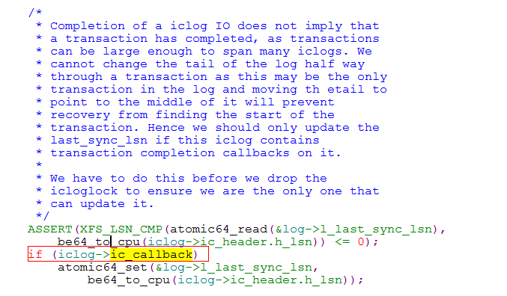

It is related to this bug:

<https://git.geekli.st/pirej/kernel/commit/7e9620f21d8c9e389fd6845487e07d5df898a2e4>

Base on the above analysis we can know the magic of inode 184549888 and dblock 8388608 is 0xd2f1.

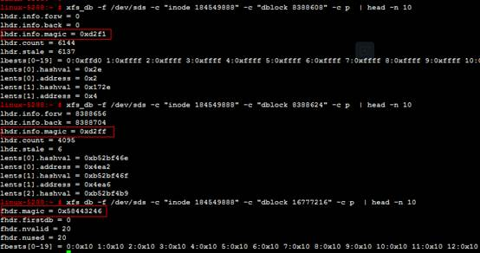

But why the process hung when access the "/home/xuensheng/tmpdir/cachefile/0000/" ?  Here is analysis:

1）

crash> bt 13710

PID: 13710  TASK: ffff883fbdfa4400  CPU: 0   COMMAND: "mkmfs:ioc-ctrl"

#0 [ffff883fb3c6b808] schedule at ffffffff8146295b

#1 [ffff883fb3c6b950] schedule_timeout at ffffffff81463165

#2 [ffff883fb3c6b9e0] __down at ffffffff81463fb8

#3 [ffff883fb3c6ba20] down at ffffffff81089ac7

#4 [ffff883fb3c6ba40] xfs_buf_lock at ffffffffa04771e9 [xfs]

#5 [ffff883fb3c6ba60] _xfs_buf_find at ffffffffa047870b [xfs]

#6 [ffff883fb3c6bab0] xfs_buf_get at ffffffffa0478856 [xfs]

#7 [ffff883fb3c6baf0] xfs_buf_read at ffffffffa0478a14 [xfs]

#8 [ffff883fb3c6bb20] xfs_trans_read_buf at ffffffffa046dd3e [xfs]

#9 [ffff883fb3c6bb60] xfs_da_do_buf at ffffffffa044139f [xfs]

#10 [ffff883fb3c6bc50] xfs_da_read_buf at ffffffffa04418a4 [xfs]

#11 [ffff883fb3c6bc70] xfs_da_node_lookup_int at ffffffffa04428a1 [xfs]

#12 [ffff883fb3c6bcc0] xfs_dir2_node_lookup at ffffffffa0449cbf [xfs]

#13 [ffff883fb3c6bd00] xfs_dir_lookup at ffffffffa0444918 [xfs]

#14 [ffff883fb3c6bdd0] xfs_lookup at ffffffffa047189f [xfs]

#15 [ffff883fb3c6be20] xfs_vn_lookup at ffffffffa047e5a2 [xfs]

#16 [ffff883fb3c6be50] d_alloc_and_lookup at ffffffff81168022

#17 [ffff883fb3c6be70] do_unlinkat at ffffffff8116ccb9

#18 [ffff883fb3c6bf80] system_call_fastpath at ffffffff8146cb92

    RIP: 00007f66a54716b7  RSP: 00007f653bba2ea0  RFLAGS: 00010206

    RAX: 0000000000000057  RBX: ffffffff8146cb92  RCX: 0000000000000000

RDX: 0000000003419e58  RSI: 0000000003419e30  RDI: 00007f653bba3960

2)

  xfs_da_node_lookup_int

   xfs_da_read_buf

    xfs_da_do_buf

           xfs_trans_read_buf

             xfs_buf_read

                   xfs_buf_get

                     _xfs_buf_find

                       xfs_buf_lock

first, the process 13710 success to obtain the lock “bp->b_sema” of blkno 8388608 on “xfs_buf_lock” and return to “xfs_da_node_lookup_int”, on “xfs_da_node_lookup_int” the blkno cannot be updated for the ” blk->magic != XFS_DA_NODE_MAGIC”(blk->magic is 0xd2f1, but XFS_DA_NODE_MAGIC is 0xfebe).

And then, the process 13710 try to request the lock “bp->b_sema” of blkno 8388608 again on “xfs_buf_lock” , this time, it is failure to obtain the lock “bp->b_sema” of blkno 8388608 and hung. This means that the process is repeated to apply the same lock “bp->b_sema” of blkno 8388608

#define XFS_DA_NODE_MAGIC      0xfebe

xfs_da_node_lookup_int(xfs_da_state_t *state, int *result)

{

   ………………………..

   ………………………..

if (blk->magic == XFS_DA_NODE_MAGIC) {

                       ………………….

             …………………

                       /*

                       * Pick the right block to descend on.

                       */

                       if (probe == max) {

                                 blk->index = max-1;

                                 blkno = be32_to_cpu(node->btree[max-1].before);

                       } else {

                                 blk->index = probe;

                                 blkno = be32_to_cpu(btree->before);

                       }

              }

  …………………..

  …………………..

}

crash>  struct xfs_da_state_blk ffff881f6d283df0

struct xfs_da_state_blk {

  bp = 0x0,

  blkno = 0x800000,

  disk_blkno = 0x0,

  index = 0x0,

  hashval = 0x0,

  magic = 0x0

}

crash>

crash> eval 0x800000

hexadecimal: 800000  (8MB)

    decimal: 8388608

      octal: 40000000

     binary: 0000000000000000000000000000000000000000100000000000000000000000

crash>

crash> struct inode 0xffff881f60e87590 | grep i_ino

  i_ino = 0xb000200,

crash>

crash> eval 0xb000200

hexadecimal: b000200

    decimal: 184549888

      octal: 1300001000

     binary: 0000000000000000000000000000000000001011000000000000001000000000

crash>

crash> struct xfs_buf_t ffff881f69f0e680 | grep b_bn

  b_bn = 0x20057100,

crash>

crash> eval 0x20057100

hexadecimal: 20057100

    decimal: 537227520

      octal: 4001270400

     binary: 0000000000000000000000000000000000100000000001010111000100000000

crash>